***Answer the following exercise.***

**Exercise 1 (5 points)**

The testicle has two functions: it produces testosterone (male hormone) and also produces spermatozoa. Sertoli cells, located in the seminiferous tubules, are involved in some of them. We deposit adjudine, a molecule that acts on these cells and modifies their activities. To understand the effect and the mode of action of adjudine, we carry out the experiments and the observation which are listed below.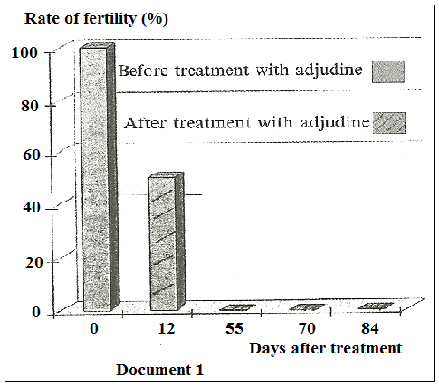

**Experiment 1:**

Fertility in male rats was tested before and after treatment with adjudine. The rats were mated with virgin and fertile females; the fertility rate is measured from the pregnancy rate in females.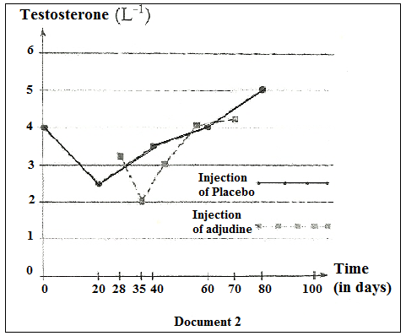

**Document 1** shows the obtained results.

1. Interpret the obtained results.
2. Justify the naming: The adjudine is considered as a “male contraceptive pill”.

**Experiment 2:**

Testosterone level is measured with respect to time in two lots of rats, one receiving an injection of adjudine and another receiving injection of placebo (medical preparation which does not contain any active substance).**Document 2** shows the production of testosterone.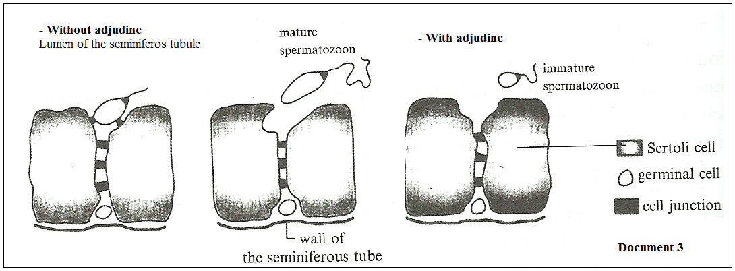

**3.** Interpret document 2.

**Observation:**

During spermatogenesis, cell junctions are formed between germinal cells and Sertoli cells. **Document 3** shows these junctions with or without adjudine.

1. Deduce the consequences of the addition of adjudine on the fertilizing capacity of the spermatozoa.
2. Explain, based on what precedes, the mode of action of adjudine and its efficiency as a male contraceptive pill.

Answer key

